Lesson 10: Answer Key 1

Key 1: Baseball Assessment

Scoring Guidance. The elements described below would be considered an exemplary response at this point in the unit. These are shown as purple text or in purple diagrams below the related question. In some cases different elements of the response are identified with a separate + symbol These +’s are not meant to be all inclusive; they are suggestions for what you may see your students include.

If several of the ideas marked with a + are missing from a student’s response, this may indicate the student has not mastered the science ideas or that the student may be struggling to bring those ideas together in a written explanation or model. Additional probing of their thinking can provide insight about whether the student is struggling with a science practice or science idea, or both. If all or almost all of the ideas marked with a + are present in a student’s response, this may indicate the student has mastered the science ideas and is able to use them in a written explanation or explanatory model.

At each level of organized baseball, there are rules in place about what type of bat and ball can be used. These rules help ensure the game play remains competitive, fair, and fun. The type of bat and ball are the two major factors that game organizers can control. But there are a lot of other factors that people claim also have a big impact on game play that cannot be controlled, such as weather conditions, location of the stadium, and the strength of the players.

Answer the prompts below to figure out how these factors could impact the game of baseball.

Weather Conditions and Pitch Speed
To the right is a graph that shows how pitch speed is affected by wind speed. The line on the graph shows the general relationship between wind speed and pitch speed. Points A, B, and C represent three of the same type of fast pitch all thrown at the same initial speed from a pitcher’s fingertips, but under different wind conditions. | 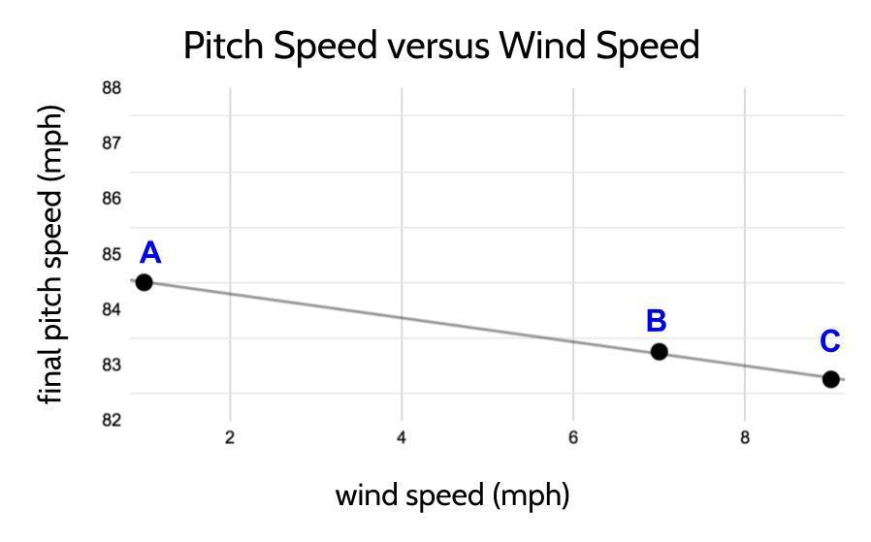  Data source: Kagan, D. (nd). The physics of pitching in the wind. Retrieved from: https://physics.csuchico.edu/baseball/Pubs/PitchingWindLong.pdf

Question 1) Draw three different free-body diagrams (A, B, and C), one for each point marked on the graph. In each free-body diagram, show all the contact forces on the ball after the ball has left the pitcher’s hand. Draw arrows to show the relative strength of forces on the ball. Make sure to include the relative strength and direction of the forces on the ball due to its interaction with the air.

A  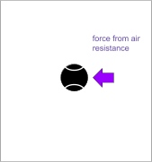 | B  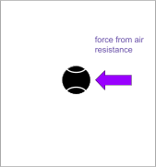 | C  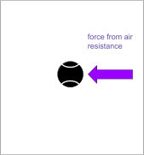

+ An arrow labeled as the force from air resistance should be on each ball.
+ The arrow should be facing to the left, with its tip touching the right side of the ball.
+ Alternatively, the images could be flipped with the arrow coming from the other direction as an alternate perspective, as long as all forces and strengths do not change in the representation.
+ The arrow length should get longer going from A to B and from B to C.

Question 2) Use your free-body diagrams on the previous page to help answer this question: If all three pitches (A, B, and C) had equal amounts of KE when they left the pitcher's hand, would they all have the same amount of KE when they reach home plate? Why or why not?
+ Pitch A would have the most KE because it is losing less energy than balls B and C to air resistance because the strength of the force from that is the smallest on ball A.
+ Pitch C would have the least KE because it encounters more air resistance than balls A and B because the strength of the force from that is the greatest on ball C.

Question 3) How would you design an investigation using materials we have used in class to collect evidence for all 3 pitches to support or refute your claim for question 2? List the items and objects you will use in your investigation. Then describe the procedures for setting up and carrying out your investigation.

The items and objects I will use in my investigation:

Baseball items | Classroom items used to simulate baseball items
Bat | Peak force detector OR a box OR a cracker
Pitcher | Spring-scale launcher
Ball | Cart with paper on it
Wind | Fan

Other items needed to collect measurements and data:

+ Peak force detector such as a push-pull spring scale OR a box to measure the total distance over which a push is applied OR a timer or radar gun or other device to collect data on the speed of the cart

My plan for setting up and carrying out my investigation:

Example:

+ I would have three different cart setups: 1 cart with a fan in front, 1 cart with a fan behind it, and 1 cart with no fan.
+ I would release each cart with the same amount of kinetic energy from the spring scale.
+ At the end of the track there would be a peak force detector placed in the same location for each cart.
+ I would measure the damage from the collision of the cart with the peak force detector at the end of the track for each condition.

Representing and Explaining the Relationships between Bat Speed and Bat Mass

The data table below shows how fast a major league power hitter can swing a bat with different amounts of mass. The mass of the bat was the independent variable in this investigation, and the speed of the bat swing was the dependent variable.
 |  | 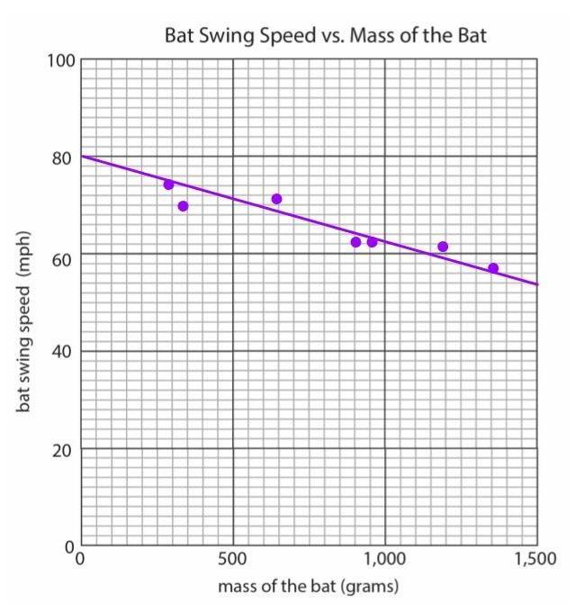
  Mass of the bat (grams) | Bat swing speed (mph)
  284 | 74
  340 | 70
  652 | 71
  907 | 62
  964 | 62
  1191 | 61
  1361 | 57
Question 4) Make a coordinate plot of the data from the table above.

Question 5) After graphing your data, draw a line of best fit for it.

+ See graphed answer above.

Question 6) Use your line of best fit to predict how fast a player could swing a bat with a mass of 779 grams. Record your prediction here:

+ The speed would be ~66 mph.

Question 7) If a batter can apply the same amount of maximum force from their hands to each bat to swing it, why would the speed of the bat swing decrease as the mass of the bat increases? Explain this in terms of a chain of cause and effect using forces, energy transfer, and kinetic energy.

+ The same amount of force will change the speed of a more-massive object less.
+ The same amount of force transfers the same amount of energy to an object, and since mass and speed are both related to the amount of KE an object has, increasing the mass of the object would require that its speed decreases.
+ It takes more energy to get something moving at the same speed as something with less mass.

What has a bigger effect on kinetic energy of the bat and the ball--increasing the speed of the bat or increasing the mass of the bat?
  Bat weight (g) | Speed of ball after contact (mph)
  570 | 68.5
  710 | 73.0
  850 | 76.2
  990 | 78.6
  1,140 | 80.4
  Bat swing speed (mph) | Speed of ball after contact (mph)
  20.5 | 60.2
  27.3 | 68.8
  34.3 | 76.2
  41.0 | 83.8
  47.9 | 91.4
Question 8) Use the data from the tables above to determine which has a bigger effect on speed of the ball after it is hit, increases in the mass of a bat or increases in the swing speed of the bat. Show any calculations you do to determine which has a bigger effect.

+ Increases in the speed of the swing have a bigger effect on the speed of the ball after it is hit.

Question 9) Some baseball stadiums (such as Coors Field in Denver, Colorado, which is the home stadium for the Colorado Rockies) are located at much higher altitude than most stadiums. Coors Field is 5,200 feet (almost a mile) above sea level. At this higher altitude there are fewer air particles in a given volume of air than at lower altitudes. Assume that the data shown in the two data tables in question 8 were collected at a stadium close to sea level (lower elevation). How would you expect the patterns in both tables to compare if you collected new data on bat weight vs. speed of ball after impact and bat swing speed vs. speed of ball after impact at Coors Field, where the air is less dense than air near sea level? Why?

Students may interpret this question from different viewpoints in which the ball could be in contact with air, which would have an affect on the speed of the ball. Any of the following viewpoints are acceptable if justified with explanations of peak force and/or energy increases to the system.

From a pitching perspective
+ The speed of the pitched ball would increase because there is less air resistance on the ball. This increases the KE of one object in the system, which increases the peaks forces in a collision, which should increase the speed of the ball after contact for every value tested.

From a batting perspective
+ The speed of the bat would increase because there is less air resistance on the bat, which allows the player to swing it faster, increasing KE. During contact, the bat’s KE increases the peak forces in a collision, which should increase the speed of the ball after contact for every value tested.

From a ball-movement perspective at the moment of contact
+ The ball won’t have moved through any air in the direction it would travel immediately after the bat contacts it (away from the bat), so the speed of the ball immediately after it is hit shouldn’t change for any of the values tested.

From a ball-movement perspective as it is traveling through the air after being hit
+ If ball speeds are measured after the ball has traveled through air a bit after being hit, the speed of the ball should be faster because there is less air resistance on the ball.

Does the type of bat affect the amount of kinetic energy in the bat and ball?
Some people think it’s important to have rules about the type of bats that players can use. For example, in major league baseball, players are only allowed to use wooden bats, while in NCAA baseball, bats made from metal and other composite materials are allowed. Titanium bats, however, are banned in most baseball clubs.
A coach argues that the reason for this is that the material the bat is made of causes it to produce higher peak forces in a collision than other bats because it deforms less in a collision. |   Warning shown on the bat label

Question 10) Does the warning on the bat label shown above support both parts of the coach’s argument about forces and deformation?

+ It supports the argument about peak forces when it says “make come off harder and faster”. Higher peak forces are related to higher amounts of kinetic energy for objects in a collision and will result in a higher speed of ball.
+ It does not support the argument that it is due to less deformation. We do not have enough data to make this claim. (If students try to make this claim by referencing ideas from Lesson 3, that is appropriate at this time. This idea will be explored further in Lessons 11-12.)

Question 11) Do you think that objects or materials that deform less in a collision spring back quicker or slower than objects that deform more? Why or why not?
+ Accept any response related to an amount of deformation and time to spring back. Some students may also connect this to peak forces and energy transfer. Any of these connections are appropriate at this time in the lesson set as they foreground relationships that they will explore in the last lessons of the unit.

Question 12) If you were playing baseball against another team and had all the data above for the other team and the conditions for that day, what single factor (wind speed and direction, elevation of the stadium, bat mass, bat swing speeds of players, bat material) would you consider the most when adjusting your game play? Why?
+ Accept all responses.
+ Rationale should reference any patterns and comparisons in the data showing a larger effect of one factor over another.
+ Note: The bigger purpose of this question is to provide a sense of closure on the framing of the entire question set that was introduced at the start of the assessment and to make the question set more relevant to students' individual experiences and perspectives.

